# 

# Great Gransden Pre-School Playgroup

## Children’s Polo & Sweatshirts order form

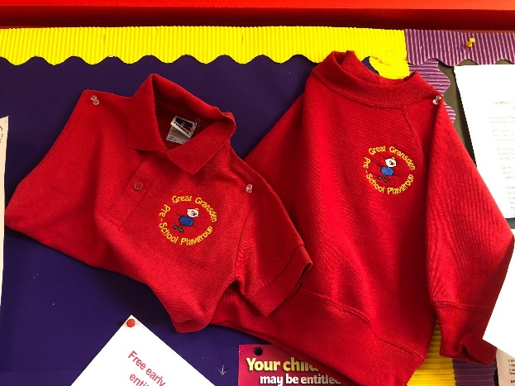

Playgroup have polo-shirts and sweatshirts with our logo embroidered on available to purchase if you wish. [optional]

Please circle your requirements below and hand the sheet to a member of staff.

**Polo shirt Colour - RED £8.50**

Size - 1-2  3-4  5-6

Quantity required?

**Sweatshirt Colour - RED £9.00**

Size - 1-2  3-4  5-6

Quantity required?

**Child’s name:**

**Do you wish to pay cash**  **BACS**  **or add to next bill** **?**

**Playgroup staff only :-** Has order been given out Y/N? Cash received?

Full or Part? Please specify.